**Final exam review for Nano-bio structure**

**January 2022**

-Prof. Rocha

Small questions: Describe briefly Ramachandran plot, stealth liposome, and DNA origami

Ramachandran plot is a way to visualize **sterically** allowed angles of two different peptide bonds. (N and O has to be on the same plane)

Expand: Anti-parallel and parallel Beta-strands.

A stealth liposome is a sphere-shaped vesicle with a membrane composed of phospholipid bilayer used to deliver drugs or genetic material into a cell. It slow down the process of being detected by the immune system of the body.

(Draw a graph for the liposome)

DNA origami: scaffold (long single DNA ring), staples (help to stick the region where it is needed)

The specificity of the interactions between complementary base pairs makes DNA a useful construction material, through design of its base sequences.

Big questions: Describe and explain DNA strand displacement and design DNA logic gate (choose either "AND" or "OR")

On slide

-Prof. Mizuno:

Describe the machinery of muscle contraction, including how the myosin converts chemical energy to mechanical energy to move on microfilaments.

Focus on the confirmational change of the Myosin.

Muscle contraction thus results from an interaction between the actin and myosin filaments that generates their movement relative to one another. The molecular basis for this interaction is the binding of myosin to actin filaments, allowing myosin to function as a motor that drives filament sliding. And it uses the energy released from ATP transformed to ADP to convert chemical energy to mechanical energy.

Explain how the action potential propagates throughout the muscle fibers.

Action potential propagates to long distances by the movement of the ions through voltage-gated ionic channels embedded in the plasma membrane of the neurons (Fig. 10). The voltage-gated ionic channels have three conformational states, for example, open, closed, and inactivation.

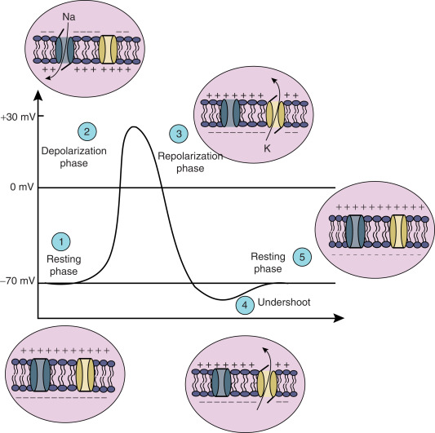

**Januari 2019**

-Prof Nies:

Give the names of 2 enantiomers of amino acids + structure

Alamine 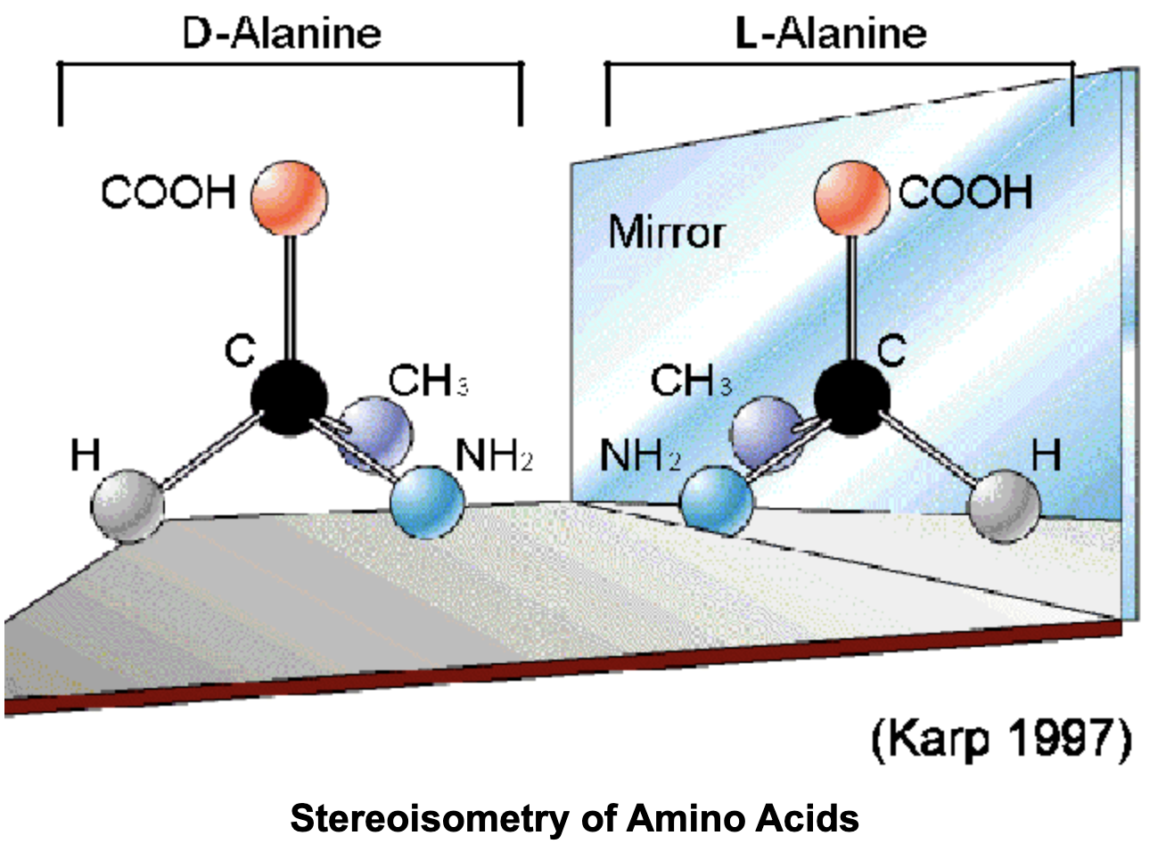

Show how a peptide bond is formed + explain peptide

A peptide is a short chain of amino acids (typically 2 to 50) linked by chemical bonds (called peptide bonds). One H and one -OH functional group from taken from NH2 and COOH, and a bond formed. One loses -OH from its carboxyl group (COOH) and the other loses hydrogen from its amino group (NH2). This reaction produces a molecule of water (H2O) and two amino acids joined by a peptide bond (−CO−NH−). The two joined amino acids are called a dipeptide.

Hydrophobic and hydrophilic: explain short + give min 1, max 3 examples why this is an important property for the protein chain.

In chemistry, hydrophobicity is the physical property of a molecule that is seemingly repelled from a mass of water (known as a hydrophobe).[1] In contrast, hydrophilic are attracted to water. Because of the polarity difference between water and protein. This phenomenon is the tendency for nonpolar surfaces to interact with each other rather than with water. The hydrophobic effect leads to the burial of nonpolar side chains in the interior of proteins, which in turn collapses polypeptide chains into compact, globular structures. Amphipathic lipids exhibit a unique behavior in water: they spontaneously form ordered molecular aggregates, with their hydrophilic ends on the outside, in contact with the water, and their hydrophobic parts on the inside, shielded from the water. This property is key to their role as the fundamental components of cellular and organelle membranes.

Force field: give + explain 2 examples each of bonded and non-bonded interactions.

Van der waals force interactions (non-bonded)

Electrostatic force interactions (non-bonded)

Harmonic potential

Harmonic angle potential

Explain one type of ensemble (which parameters are fixed etc) + what is needed to control this variables (thermostat for example)

NPT ensemble, N-particle number, P-pressure, T-temperature are fixed, and total energy E and volume V are needed to be calculated. Isobarotic and thermostat are needed.

Maglia:

Explain how nanopores can be used for DNA sequencing

Nanopores used DNA sequencing is the third generation DNA sequencing technology. It is real-time, fast speed, low cost, and possible detection when DNA concentration is low. First, highly charged single strand DNA is captured by the electrical field. Then ssDNA goes through the nanopore in a controlled translocation speed. A single base resolution of ion current change through the nanopore is detected. Due to the sizes of the nitride-bases, the blockage currents are different. This is why we can use nanopores for DNA sequencing.

Mizuno:

Explain the fluorescence mechanism of the sequence SYG, based on the chemical structure of the amino acids (which is provided). Explain how can these structures be modified/mutated to achieve other colors (blue, Cyan, yellow). Based on these, explain how FRET technique can be used to analyze different structures.

GFP is short for green fluorescent protein. GFP is built from 11 beta strands, with an alpha helix inside the middle. The reason for the fluorescent effect is because of 3 amino acids running through the center of the beta strands barrel. Serine, glycine and tyrosine are so close together that their chemical groups simultaneously bind together into GFP chromophore, which is fluorescent whenever there is oxygen around. If we want different colors, we can mutate the key amino acids around this chromophore motif. The light emitting properties of GFP can be changed by altering the structure or stability of the chromophore. FRET provides an efficient way to measure the distance between a donor and an acceptor chromophore. It can determine structures of protein by detecting wavelengths of light emitted from one molecule and absorbed by the other molecule.

**Januari 2018**

-Prof Hideaki

A question about fluorescence (yes, he does still sometimes ask about it, it's not all about molecular motors). Explain the fluorescence mechanism of the sequence SYG, based on the chemical structure of the amino acids (which is provided). Explain how can these structures be modified/mutated to achieve other colors. Based on these, explain how FRET technique can be used to analyze different structures.

SYG sequence can go through different self-reactions to form chromophore.

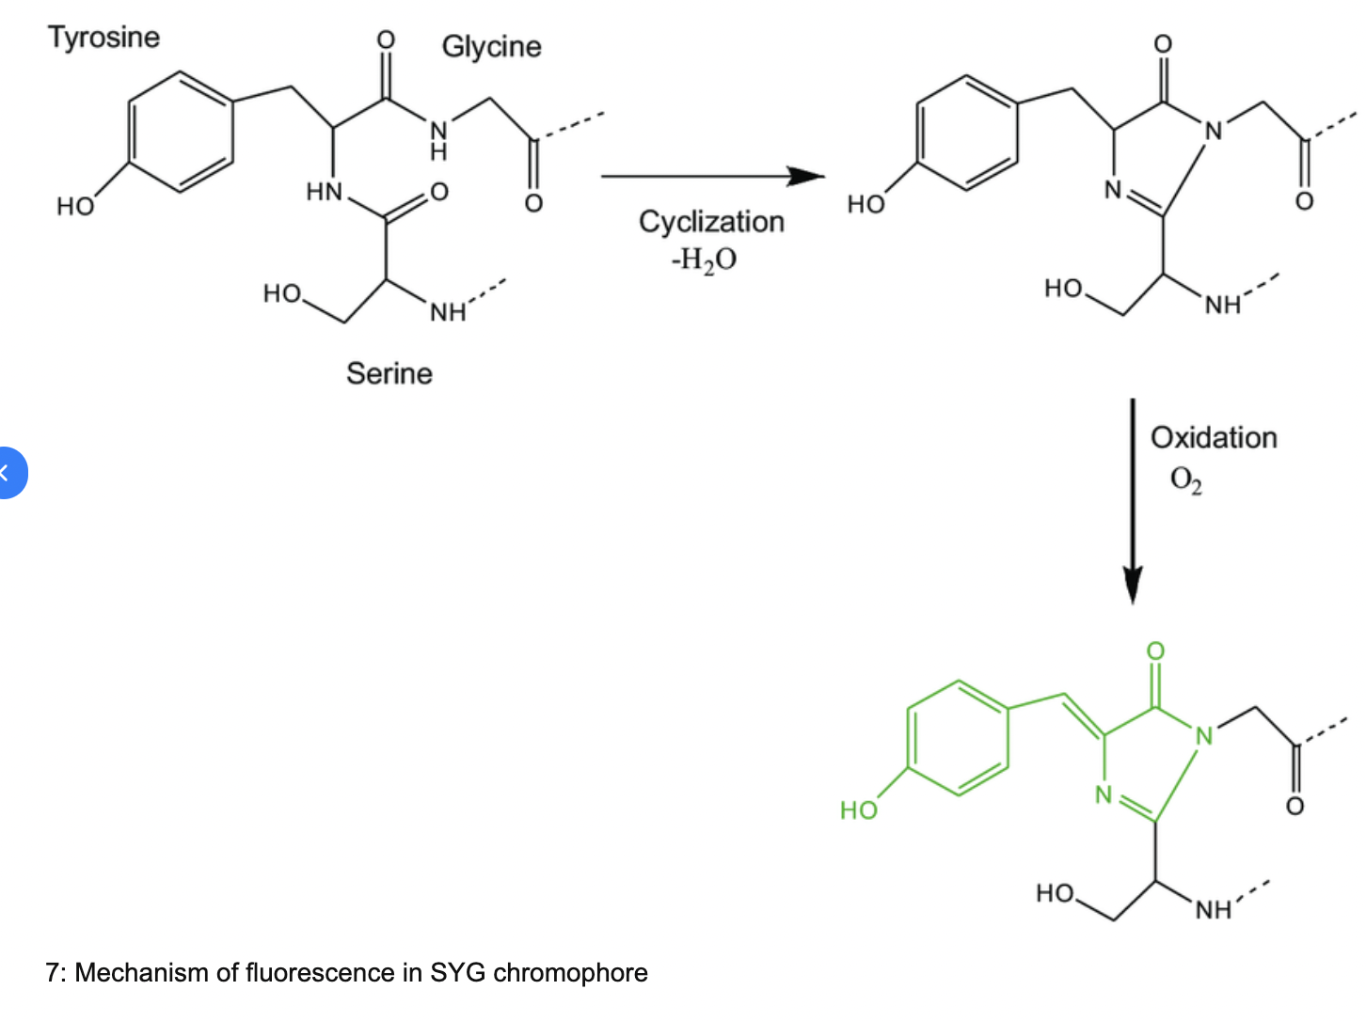

Chromophores contain ring-structures in which there are pi-bonds. Electrons staying in steady state of pi-bonding can be excited to pi-antibonding state and when they jump back to the ground state, they will release a certain frequency of phonons corresponding to the energy difference between these two states.

To achieve other colors, e.g. CFP, YFP, RFP etc., different mechanisms might involve. Different structures of mutants of chromophores might provide various energy level difference, thus giving rise to different colors. YFP has two layered chemical structure.

FRET technique is based on Forster’s resonance energy transfer theory. CFP and YFP can be related by other linkage proteins. And Ca2+ can induce the distance change between these two chromophores and the energy emitted by one chromophore can be absorbed by the other chromophore, as a result, the other color will be shown. However, there are certain requirements to this technique. I.e. the distance of the two chromophores, the energy difference between the energy absorption of one chromophore and the emission of the other chromophore also need to be close to each other, as well as their dipole moment needed to be aligned.

-Prof Maglia

Talk about an 'application' of proteins --> Choose your own topic (like spider silk) to talk about

Protein as nanopores used for DNA sequencing:

Using protein based nanopores, DNA sequencing can be easily achieved by gliding through the pore the ssDNA and measure the ionic current disruption i.e.different purines and pyrimidines will give different currents based on which sequencing can be achieved with instantaneous electronic pulses. Nanopores can be engineered to control its size or fix positive charges on the inner walls of the pore so as to limit the translocation speed.

**8 January 2016**

Prof Mizuno

Explain every thing you know about Muscle Contraction / Myosin, and plot as much as you can. and some terms to be clarified during your answer like ( P-loop, Sarcomere, T-tubules......etc).

Skeletal muscle are composed of muscle fibers which in turn are made of repetitive functional units called sarcomere. Each sarcomere contains many parallel, overlapping thin (actin) and thick (myosin) filaments. The muscle contracts when these filaments slide past each other, resulting in a shortening of the sarcomere and thus the muscle. Cross-bridge cycling forms the molecular basis for this sliding movement. Muscle contraction is initiated when muscle fibers are stimulated by a nerve impulse and calcium ions are released. The troponin units on the actin myofilaments are bound by calcium ions. The binding displaces tropomyosin along the myofilaments, which in turn exposes the myosin binding sites. At this stage, the head of each myosin unit is bound to an ADP and a phosphate molecule remaining from the previous muscular contraction. The myosin heads release these phosphates and bind to the actin myofilaments via the newly exposed myosin binding sites. The two myofilaments glide past on another, propelled by a head first movement of the myosin units powered by the chemical energy stored in their heads. As the units move, they release the ADP molecules bound to their heads. The gliding motion is halted when ATP molecules bind to the myosin heads, thus severing the bonds between the myosin and actin. The ATP molecules are now decomposed into ADP and phosphate with the energy released by this reaction stored in the myosin heads, ready to be used in the next cycle of movement. The myosin heads resume their starting positions along the actin myofilament, and can now begin a new sequence of actin binding. The presence of further calcium ions will trigger a new cycle

Prof Maglia Giovani

Chose one of the following Question:

2D and 3D structures question. principle and application.

DNA Strand Displacement. principle, applications.

• The speed of displacement can be controlled by the strength of the toehold

• GC rich toehold will hybridize faster

• Longer toeholds will hybridize faster

• Sequences of multiple displacements can address individual devices in a sequence-specific manner.

• circuits based on strand displacement cannot be easily recharged

There’re several applications for DNA strand displacements. DNA walkers, DNA computations. basically, lower thermal potential will lead the reaction happened, and longer the matched strand, and higher CG contents, more possible the reaction will happen.

Explain a Re configurable self assembly structure. << this is a part of the paper of Strand displacement.

**26 January 2015**

Oral parts by prof. De Maeyer and prof. Mizuno

Prof. Maglia

One of both:

Dynamic DNA nanotechnology by strand displacement: basic principle, examples and applications.

Strand displacement is achieved via toehold mechanism i.e. Sticky ends exposed will be the initial location of “invasion” by another ssDNA whose sequence is complementary with the sticky ends. By invading through “toehold”, branch migration will follow and finally strand displacement will complete once the invader has had its complementary sequence perfectly H-bonded to the original polynucleotide.

E.g. if we have a dsDNA sequence with a sticky end and another ssDNA which shares a complementary sequence with this “toehold” (of course it should also share a longer complementary sequence than the shorter chain of the original ddDNA), it will invade from this toehold and gradually replace the original ssDNA.

Applications making use of strand displacement could be “DNA Walker”, “DNA computing” and etc. DNA walker could be used for transportation of “cargo”. There are two ssDNA which serve as two legs. Those legs share complementary sequence with the “track” which consists of short single strand of nucleotides fixed on a substrate. By adding two different “fuels” respectively and separately, the leg that is behind will always be released and can then move forward, one step at a time, this DNA walker can gradually walk along the track.

Nanopores can be used to sense molecules.

Describe:

the basic principle nanopore sensing

what and how analytes can be detected with nanopores

limitations and how to overcome such limitations

Nanopore sensing makes use of the resistance of nanopore when there are different molecules passing through it. By applying a voltage across the two sides of the nanopore, we can directly measure the current. When a molecule is passing through it, the resistance will increase dramatically, thus a current drop can be detected.

1. The magnitude of the signal drop is related to the size of the molecule. Large molecules can induce a larger change in current.
2. The frequency of the signal reflects the concentration of the molecule since higher concentration means a higher probability of one molecule passing through the pore.
3. The time of one current drop reflects the translocation time. If translocation time is too short, there’s a probability that the signal will not be detected. Translocation time can be mediated by modifying the size of the pore, the electrolytes used in this “circuit”, or other techniques, e.g. fixing charges on the inner walls of the nanopore will slow down the translocation time of an oppositely charged molecule.

Prof. Nies

Question 1

Explain the following concepts and definitions:

Δmixg</math>

coexistence curve

spinodal

critical state

LCST

Figure 1 gives a graphical presentation of Δmixg. Discuss how one can "see" and/or determine the different definitions (b-e) in graphical presentations such as in Figure 1.

To support your discussion, you can make use of more typical graphical presentations like that in Figure 1.

Question 2

A monodisperse polystyrene (PS) has a molar mass M = 480 kg/mol. The molecular formula of PS is -(CH2-CH(C6H5))n- and the chemical structure can be written as

figure of structure

calculate the contour length

calculate the unperturbed average quadratic end-to-end distance and radius of gyration of the PS molecule

calculate the number of Kuhn segments and the Kuhn length of the polystyrene chain.

Some data: C-C bond length = 0.154nm, C-C-C bond angle θ = 109°

molar mass C = 12g/mol, molar mass H = 1g/mol, C∞=9.8

Prof. Mizuno

Describe how myosin and kinesin convert the chemical energy to the mechanical energy. What are roles of the P-loop and the relay helix? Give an example of biological phenomenon using respective motor proteins and explain. The answer should be understandable for layperson, and use schematic drawings.

The cytoskeletal motor proteins associate with their filament tracks through a “head” region, or motor domain, that binds and hydrolyzes ATP. Coordinated with their cycle of nucleotide hydrolysis and conformational change, the proteins cycle between states in which they are bound strongly to their filament tracks and states in which they are unbound. Through a mechanochemical cycle of filament binding, conformational change, filament release, conformational relaxation, and filament rebinding, the motor protein and its associated cargo move one step at a time along the filament (typically a distance of a few nanometers). The identity of the track and the direction of movement along it are determined by the motor domain (head), while the identity of the cargo (and therefore the biological function of the individual motor protein) is determined by the tail of the motor protein. One example is muscle contraction. Muscle is composed of repeated units called sarcomeres, and there are actin and myosin. When myosin detects a signal of Ca2+, muscle contracts, the head of myosin attached on the actin is evoked by the ADP, and a new ATP is attached on the head hydrolyzed to ADP and again to move the myosin.

Prof. De Maeyer

You retrieve the coordinates of a PDB-protein structure from the databank. How would you evaluate if the model is OK?

Enumerate as many tests that you could think off, to do such an evaluation and clarify why these criteria are valid. You may want to use the formularium.

X-ray protein structures from the PDB do not always contain all the atom positions. Sometimes some of the side-chains are not solved in the electron density. How could you optimise these side-chains atom-coordinates after sprouting the missing atom-coordinates?

**Januari 2014**

Prof de Maeyer

How do you characterize H-bonds and Salt bridges in Force Fields(formularium given)? Discuss H bonds in more detail

Give the polar non charged amino acids

Prof Mizuno

A certain process (forgot name) is used to carry cargo radially to the edge of a cell, discuss how this can happen (obviously Kinesin and Microtubule). Use the words neck linker, relay helix, dynamic instability, P-loop, Centromere, etc.

One of the motor protein that carries cargo along side of microtubules is kinesin. Kinesin consists of a coiled coil that connects the “cargo” and two heads which are in charge of the motor function. In each head, there is a p-loop serving as the nucleotide-binding domain which performs ATPase activity and provides energy by hydrolysis of ATP. Normally, ADP is binded to this domain. When one motor head is binded to microtubules (via microtubule-binding site), ADP will be released and ATP will replace, which triggers dynamic instability, that is, the relay helix leading to conformational change and the neck linker will rotate in a sense to “throw” the other motor forward. This second motor undergoes the same process by releasing ADP and binding ATP, followed by conformational change and “throwing” the other leg forward. The cycle keeps on going and kinesin can transport cargo along side of microtubules(from minus end to positive end).

Prof Nies

Given an formula for Flam and Fhom, determine the condition for Chi*N for the transition (Basic math). Give a formula of Chi in function of N.

What does the Gibs free energy of mixing of a solution of a polymer in solvent look like, in function of the volume fraction of polymers? Given the global volume fraction and the volume fractions of the different phases. Discuss the interesting properties of the graph (Mainly binodal and spinodal points).

Prof Maglia (answer 1 out of 2 questions)

Explain nanopore sequencing (Different technologies, how to detect a base, issues, solutions)

Explain Dynamic DNA nanotechnology

January 2013

Prof de Maeyer

Salt bridges are charge-charge interactions. Where in a protein would you put them to stabilize it (formularium given)?

Give the aromatic hydrophobic amino acids

Prof Mizuno

Explain the principle behind kinesin movement on microtubules.

Kinesin has two globular heads that enable it to walk along the microtubules. Pulling the cargos to their destination. Each foot possesses special locations called binding sites that interact with other molecules. One site attaches to the microtubules, and the other binds a ATP, the energy molecule of the cell. When one foot binds with ATP, and uses its energy which is the hybridization of ATP to ADP and Pi, the foot flips over, resulting in a walking motion. Each foot has a short neck, which is connected to a strand of a long coiled stalk. At the end of the stalk is a fan-shaped tail which holds tightly to the cargo being transported.

Prof Nies

Question about polymer calculations (cf exercise session)

Calculate the dependence of diblock polymer long period length on parameters

Prof Maglia (answer 1 out of 2 questions)

Explain nanopores

Explain protein technology

Prof Nies, modeling and predictions

In Force Fields, used for molecular systems, it is custom to make a distinction between

bonded and non-bonded interactions. For each type of interaction give 2 examples and briefly

explain which interaction they represent.

Bonded interaction: stretching, bending, rotating of the bonds (restoring force induced by these movements)

Non-bonded interaction: electrostatic interaction(between oppositely-charged molecules), Van der Waals interaction(weak interaction of non-polar molecules).

- According to equilibrium thermodynamics a macroscopic system is governed by a limited set

of state variables, e.g. the Gibbs energy G of a single component system depends on the

number of particles N, temperature T and pressure p. In simulations the thermodynamic

properties can be studied using the method of ensembles. Frequently used ensembles are the

microcanonical ensemble, the canonical ensemble and the isothermal-isobaric ensemble.

Indicate the variables that are controlled in the simulations and which state variables are

measured in the simulation. Discuss how the controlled of the variables is achieved in the

Simulation.

Microcanonical Ensemble(NVE):

External variables: N(particle number) V(volume) E(total energy)

Observables: T(temperature) P(pressure)

If one wants to perform simulations with constant temperature or pressure. A modification of molecular dynamics is needed to increase or decrease energy or volume so as to keep T and P constant in the simulations.

Canonical Ensemble(NVT):

External variables: N(particle number) V(volume) T(temperature)

Observables: E(total energy) P(pressure)

A thermostat(algorithm) is required to modify the total energy in order to keep a constant temperature.

Isothermal-isobaric Ensemble(NPT):

External variables: N(particle number) P(pressure) T(temperature)

Observables: E(total energy) V(volume)

A barostat is required to modify the volume such that the pressure can be kept constant.

- Classical Force Fields result when making approximations to solve the quantum mechanical

problem expressed in the Schrödinger Equation. Give the different steps that give rise to

defining a classical Force Field.

A molecule contains M nuclei and N electrons. The mass of electron is way lighter than nuclei, thus, it can be approximated that the electrons are moving in a fixed nuclei matrix (Born-oppenheimer approximation). The schrodinger equation can be simplified by using electronic hamiltonian and solve only the electronic part. Once we have the result of electrons of movement, the movement of nuclei can be solved classically(Newton’s second law of motion) by assuming them moving under an averaged electronic clouds(wave function). The interaction involved for the nuclei are approximated by empirical models. i.e. E=Enon-bonded+Ebonded

A classical force field consists of potentials between non-bonded atoms and bonded atoms. For non-bonded ones, electrostatic interaction for charged molecules and Van der Waals interaction for non-polar molecules are taken into account. For bonded one, the stretching, bending and rotating potentials are considered by using empirical formula.

- Give a to the point and concise description of the principle of a classical Molecular

Dynamics (MD) simulation.

Molecular dynamic simulation is used to calculate the dynamic motion of a finite molecular system. Each system can be regarded as a finite number of molecules with initial individual positions and initial velocity. By calculating the force exerted on each molecule(force model, often acquired by considering both bonded and non-bonded interactions) and by applying a small delta t over the force, according to Newton’s second law of motion, a new set of location and velocity can be obtained. A large number of cycles are executed, which gives rise to the trajectory of the molecules of interest.

A general process of MD consists of the following steps:

1. Set the initial values(location and velocity) for all the molecules in the system.
2. Update neighbor list
3. Get force
4. Solve equations over delta t
5. Perform p,t control
6. t=t+delta t
7. Calculate the desired physical quantities

(repeat the cycle until reaching expected simulation time)

- In an MD simulation we can only study a finite (small) system but often we want to simulate

a bulk system, i.e., an infinitely large system. How is this problem solved in MD? This

solution is only an approximation to the real system. Can you think of problems that can

occur with this method?

1. Periodic boundary conditions are employed to calculate an infinitely large system by assuming a finite simulation cell. Minimum image convention is adopted, that is, each particle can only interact once with a given particle, by the particle proper or by its periodic image, whichever is closer.

If the periodicity of the system is not well defined, this method might include lots of errors and those errors can accumulate and finally distort the result.

1. Using neighbor list that ignores the atoms that are too far away from the atom of interest without sacrificing too much accuracy. At regular time, update the neighbor list.

Questions on Coarse graining

- Explain why, e.g. the Brownian motion of a fat droplet in milk is extremely difficult to treat

in all atomistic detail and how coarse graining can help to make progress.

The difference in size between a fat droplet in milk with its surroundings(water molecules) is large, thus the time scales for these two types of molecules varies tremendously. In order to calculate the force and movement of water molecules, we need to apply a way smaller time scale to the point that it will take an “infinitely-long” time to reach the time scale that we should consider for the milk droplet. As a result, it would be practically impossible to solve MD for this type of system.

Coarse graining ignores the accuracy in the motion of the smaller system(water molecules) by giving the whole water system a certain property(e.g. Friction coefficient) and treat it as a medium rather than individual molecules. In this sense, the high frequency component of MD simulation is smoothed out and we are only interested in the fat droplet’s motion in a “viscous” liquid that can be controlled globally by certain parameters to represent its ability to influence the larger particles.

- Explain the Langevin equation (friction forces, random forces, Fluctuation dissipation

Theorem).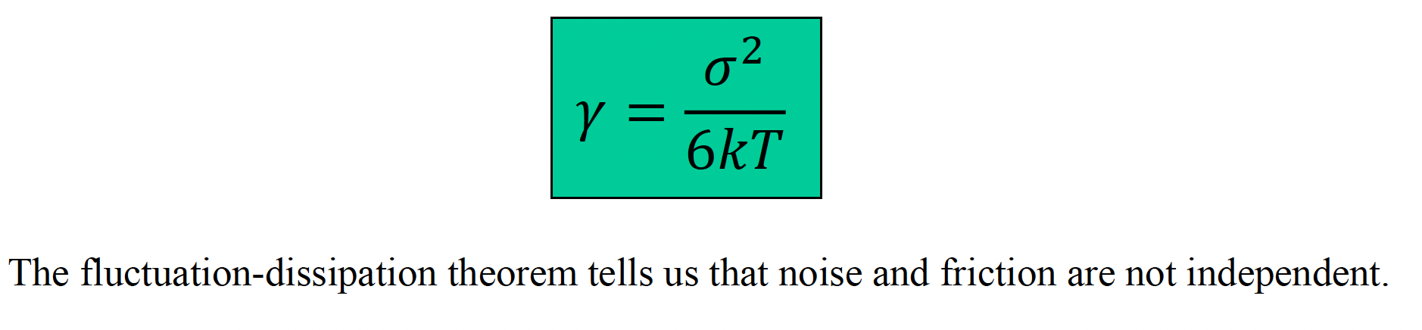

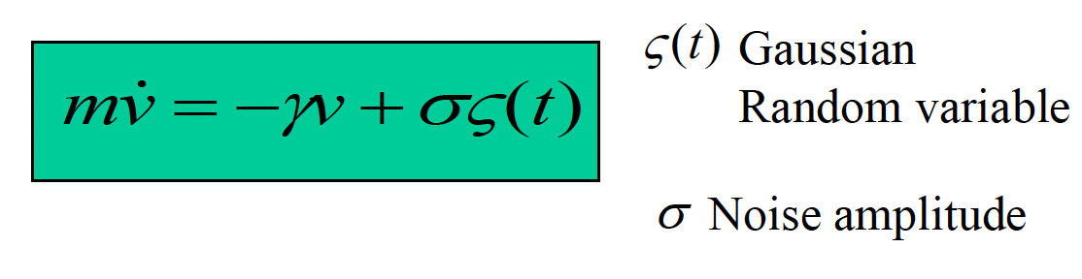

Langevin equation is given above. The first term describes the average frictional force produced by smaller molecules and experienced by the larger molecules. Gamma is frictional coefficient used to characterize the medium. But if the larger molecules only experience frictional force, it will reach an equilibrium state and the velocity will decay to zero, which is in contrary to the theorem of equipartitioning, that is, the average velocity of molecules should be . Therefore, the second term is added to the system, which represents the random force (noise) that the larger molecule will also experience.

Solving Langevin equation and let , we can get the fluctuation-dissipation theorem indicating that the noise and friction are not independent.

- Extend the Langevin equation to more particles.

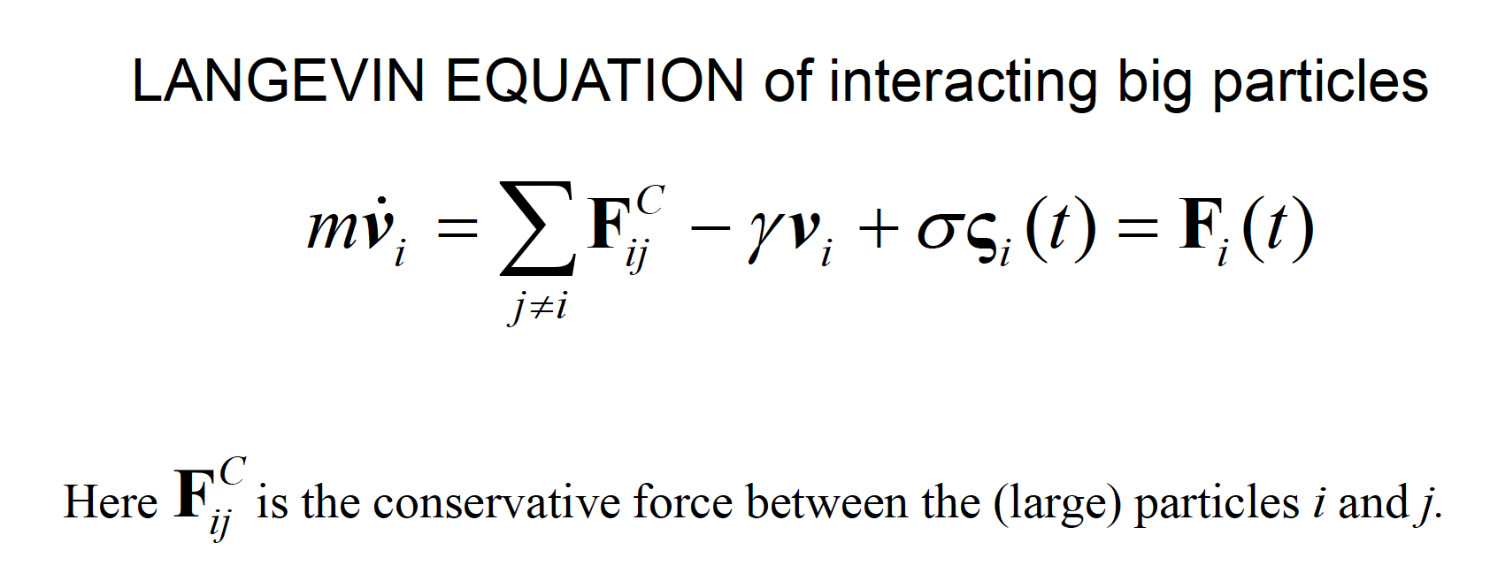

To extend the Langevin equation to more particles, we need to consider the conservative forces between solvents(large particles) by adding another term F to Langevin equation. Fij can be obtained by coarse graining or simply using empirical potentials i.e. bond length, angle, torsion.

- Discuss the approach and the steps of systematic coarse graining starting from detailed information.

1. Choose a CG system, that is, number of atoms that we consider to be a unit.
2. Perform microscopic (atomistic) simulations of short macromolecules (oligomers) for short times.
3. Develop the effective CG force field using the atomistic data configurations.
4. CG simulations (MD or MC) with the new coarse grained model.
5. Re introduction ( back mapping ) of the atomistic detail if needed.

- What are the consequences of the coarse graining for the dynamics in a coarse grained

molecular dynamics simulation.

Coarse graining will remove certain degrees of freedom by considering a certain number of small molecules as a unit and perform MD simulation. It will smoothen out the energy landscape(avoid local minima) while maintaining useful information(e.g. Global minima). As a result, we can not directly get the atomistic motion, however, by using back-mapping, it is possible to get more atomistic details.

Other possible questions

Excerpt of a research paper related to the simulations and results used in that paper can be

provided. The question will then be related to connect the information in the excerpt to the topics

discussed in my part of the course.